ES2631 Critique and Communication of Thinking and Design
AY2025/2026 Semester 2
Week 2
Engineering Reasoning Framework: Elements of Thought
Lesson Objectives
By the end of this week’s lesson, you will be able to:
- Understand the key components of the Engineering Reasoning Framework (ERF)
- Understand the eight elements of thought in the framework
- Identify the elements of thought in a non-engineering situation
- Identify the elements of thought in an engineering related situation
- Understand Assignment 1 requirements and timeline
- Identify and reflect on the intellectual traits you have or wish to develop (pp. 6-8)

Course Introduction and Expectations
- Course introduction
- Setting expectations
- Individual introductions

Introduction
The Engineering Reasoning Framework (ERF) (Paul et al., 2019) is a tool for analysing and evaluating engineering reports, texts, articles, designs, graphics, and, more broadly, approaches and practices within the discipline. It is also adaptable to other domains of life and thought.

The primary goal of the ERF is to develop “mature engineering thinker(s)” who embody the eight intellectual traits essential for effective critical thinking (Niewoehner, 2006).

At its core, the ERF is built upon eight elements of thought, which underpin all thinking. These elements serve as a framework for evaluating both our own and others’ reasoning. Deconstructing thought involves identifying these elements, as illustrated in the following statement:
“Whenever we think, we think for a purpose within a point of view, based on assumptions, leading to implications or consequences. We use information such as data, facts and experiences to make inferences and judgments, based on concepts and theories, to answer a question or solve a problem” (Niewoehner, 2006; Paul et al., 2019).

Recap and Review of Framework

Based on this week’s lecture:
- What are the eight intellectual traits that a critical thinker should develop? (pp. 6-8)
- What are the eight elements of thought in the Engineering Reasoning Framework (Paul, Niewoehner & Elder, 2019)? What does each element of thought refer to/ mean? (pp. 10-15)
- What are the nine intellectual standards? How do they relate to the elements of thought? We will return to the intellectual standards later in the semester.

Activity 1 - Identifying Elements of Thoughts in Non-Engineering Examples

Before diving into engineering cases, let us explore how the elements of thought operate in a situation most of us have faced—whether or not to exercise the S/U option (National University of Singapore Office of the University Registrar, n.d.).

Analysing everyday scenarios helps you realise that critical thinking frameworks such as the ERF are not just academic tools but also useful in everyday life. This warm-up activity will help you recognise and apply the eight elements more easily when you tackle engineering problems next.

Scenario: Exercising the Satisfactory/Unsatisfactory (S/U) Option

1. Purpose
What are we trying to accomplish?

2. Question at Issue
What question are we trying to answer?

3. Information
What data do we have/need?

4. Inference
What conclusions are we drawing from the information?

5. Concepts
What theories, models, or principles apply?

6. Assumptions
What are we taking for granted?

7. Implications
What are the possible outcomes or results of this policy?

8. Point of View
Whose perspective are we considering (or ignoring)?

Activity 2 - Identifying Elements of Thoughts in Engineering Example: Worked Example

In this activity, we will discuss and identify the elements of thought based on the thinking and design of the Electronic Road Pricing (ERP) system in Singapore. Some background information on the system is provided below but you may refer to Goh (2002) for a more in-depth understanding.

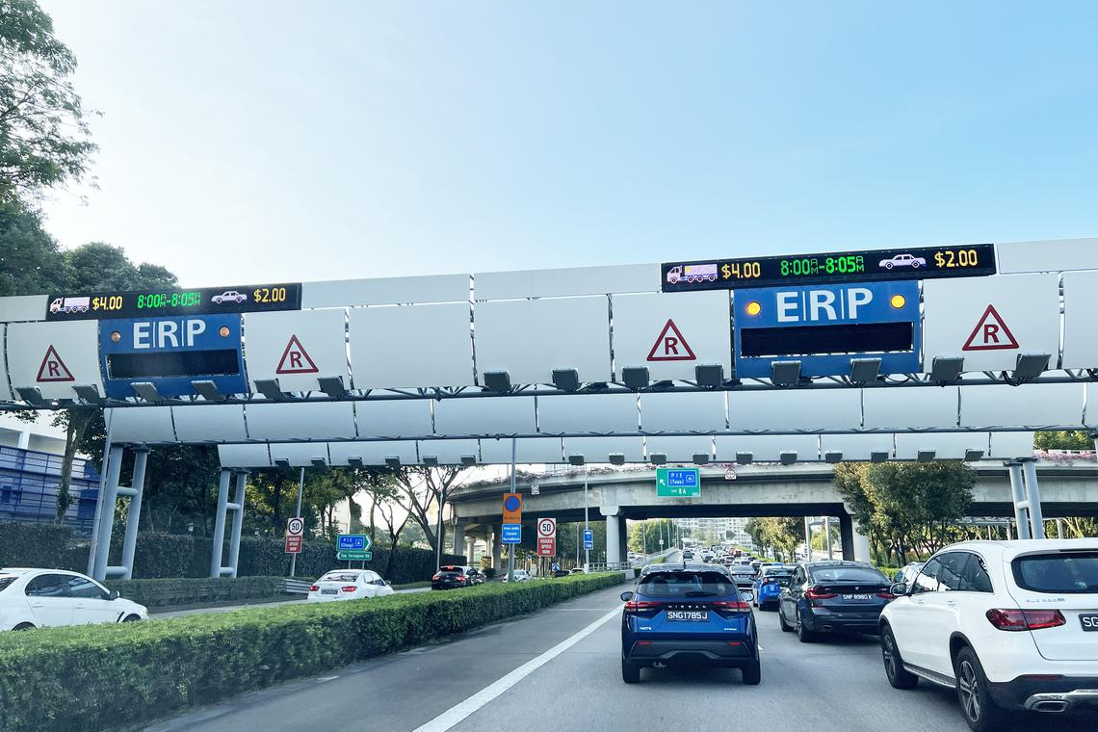
(Source: The Straits Times)

Background: The ERP system was introduced as a response to the growing problem of road congestion in the city-state. Building on earlier congestion management efforts, the ERP was implemented in 1998 as a technologically advanced, pay-as-you-use road pricing mechanism designed to regulate traffic volumes in real time. The system automatically charges motorists for using specific roads during peak hours, with the main objective of encouraging drivers to modify their travel behaviour—such as changing routes, shifting travel times, or using public transport—in order to reduce congestion on busy roads (Goh, 2002).

The rationale behind the ERP is both practical and economic. Rather than expanding road infrastructure endlessly, Singapore’s approach uses pricing as a tool to manage limited road space efficiently, ensuring smoother traffic flow and minimising the negative externalities of urban congestion. This system has positioned Singapore as a global leader in urban transport management, serving as a model for other cities facing similar challenges (Goh, 2002).

Now, let’s put ourselves in the shoes of the Singapore Government. As policymakers, our task is to analyse the thinking and reasoning behind the design and implementation of the ERP system.

1. Purpose
What are we trying to accomplish?

2. Question at Issue
What question are we trying to answer?

3. Information
What data do we have/need?

4. Inference
What conclusions are we drawing from the information?

5. Concepts
What theories, models, or principles apply?

6. Assumptions
What are we taking for granted?

7. Implications
What are the possible outcomes or results of this policy?

8. Point of View
Whose perspective are we considering (or ignoring)?

Assignment 1 Reviewing requirements, forming groups and brainstorming
Refer to Assignment 1 task sheet and clarify any doubts with your tutor.
Form a group of 3 and give your names to your tutor.
Use the rest of class time to brainstorm and research potential topics for Assignment 1.
Homework
Reflect on the eight intellectual traits identified by Paul et al (2019) as essential to being a mature critical thinker. Which of these traits do you possess, and which do you wish to develop?

Write a paragraph of about 80-100 words on ONE trait that you either exhibit OR wish to develop:
- For a trait that you exhibit, explain how you developed this trait and provide examples of how you exhibit this trait in your thinking.
- For a trait you wish to develop, explain why and provide examples of how this trait could be developed (i.e., your action plan) and/or how it would be exhibited in your thinking in future.

Please upload your paragraphs to MS Teams by Saturday, 24 Aug 2026
Review the Sources lecture and handout (including plagiarism and AI use policies) in preparation for Week 3 and to firm up topics for A1.

References

Goh, M. (2002). Congestion management and electronic road pricing in Singapore. Journal of transport geography, 10(1), 29-38.

Menon, G., & Guttikunda, S. K. (2010). Electronic road pricing: Experience & lessons from Singapore. SIM-air Working Paper Series, (33-2010).

Niewoehner, R. J. (2006). Applying a critical thinking model for engineering education. World Transactions on Engineering and Technology Education, 5(2), 341.

National University of Singapore Office of the University Registrar. (n.d.). Continuation and graduation requirements [Webpage]. National University of Singapore. Retrieved July 30, 2025, from https://www.nus.edu.sg/registrar/academic-information-policies/undergraduate-students/continuation-and-graduation-requirements#SU

Paul, R., Niewoehner, R. & Elder, L. (2019). The Thinker’s Guide to Engineering Reasoning: Based on Critical Thinking Concepts and Tools. Rowan & Littlefield Publishers.

